|  |
| --- |
| **Restricted Boltzmann Machine** |

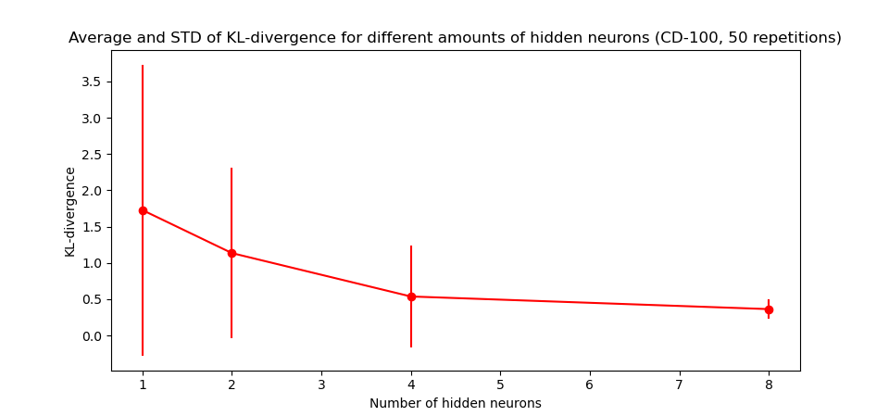

Fig. 1 : Graph showing the results of the KL-divergence after training the Boltzmann machine for different values of M

Comparing figure 1 to the theory presented in the lecture, we can see that we do not get as close to zero after the critical M limit of 3 as we could have expected. This is probably because of the limited amount of precision we were able to get in the KL-d algorithm (I had to restrict the amount of sampling to 300 x 1000 dynamic steps due to the limited computing power available to me).

Furthermore, a surprising result was the sometimes negative value obtained for the KL-d, in theory always positive. An explanation for this is the fact that we could only compute a limited amount of trials to average over, and in some we encountered.

Overall, we do get a trend and values coherent with the ones presented in the lectures.